**DETECTION OF UNAUTHORIZED PARKING USING RFID**

Sunny Rana1, Shahid Imran1, Shubham Mathur1

Gunjan Aggarwal2

1Student, 2Asscociate Professor (Guide), Department of Computer Science & Engineering, SET, Sharda University, Greater Noida, India

**Abstract.** A considerable extent of work force is set up to check for unauthorized parking and fine the ones at fault. But most people escape the fine by numerous illegal means like bribing the worker, threatening them by the use of their power, etc. Towing vans are also required in the case for manually searching the illegal parked vehicles. This system requires large expense in terms of the requirement of workforce, settlement, feed, gas and other physical supervision. We have proposed a system that grants and provides an automated detection and alert system for illegally parked vehicles. This system comprises of installing an RFID transmitter in every car, jeep, bus, cab, etc. The RFID receiver circuits are established in most of the place wherein parking is illegitimate. Once a vehicle is parked in a no parking area and the RFID transmitter comes in the scope of the receiver circuit, the RFID reader scans and reads the transmitter unique id and can alert the concerned regulating authority with the code of the area so that authorities can directly reach the spot and an SMS is also sent to the car owner by the system about the fine being imposed on the vehicle.

KEYWORDS : RFID ,

**I. INTRODUCTION**

Now days in many public places such as supermarkets, offices, hospital area, market areas there is a significant problem of unapproved car parking. This creates a problem on the road for the people and as well as for the authority to trace the car owner and to clear the obstruction. Moreover, the current system comprises of a lot of man labour, setup and speculation. So, there is a need of developing an labour saving system that indicates directly the location and the details of a car parked in an unauthorised parking area[2]. This system includes an RFID transmitter that is attached in every vehicle[3]. In areas where parking is prohibited a RFID receiver circuit is mounted. If a car is parked in an unauthorized area, the RFID detector detects the car [1] and sends the notification message to the driver regarding the wrongly parked car.[4]

A. LIQUID CRYSTAL DISPLAYs (LCD)

The 20x2 and 16x2 displays are one of the most used LCDs that are integrated to the microcontrollers. This simply means 20 characters per line by 2 lines and 16 characters per line by 2 lines and, respectively. The standard is referred to as HD44780U, which communicates directly with the LCD and indicates to the controller chip which receives data from an external source .

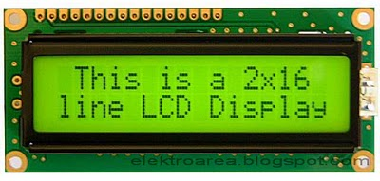

Figure.1 LCD display

B. RFID READER

From ID Innovations, this is a very simple to use RFID reader module. The only holdup is the 2mm pin spacing with a built in antenna. Powering up of the module,  keeping up a card, and getting a serial string output containing the particular identity of the card.

Figure.2 RFID module

C.GSM MODULE

SIM 800A is a Tri band GSM/GPRS engine that works on various frequencies like 900MHz, 1900MHz, and DCS 1800. With conFigureuration of 40mmx33mmx2.9mm, SIM 800A can meet almost all the space requirements like in smart phone, PDA phone and other devices. The physical interface provides all hardware interfaces between the module and customers’ boards and the RF antenna that interfaces to the mobile application is a 60 pin board t board connector.

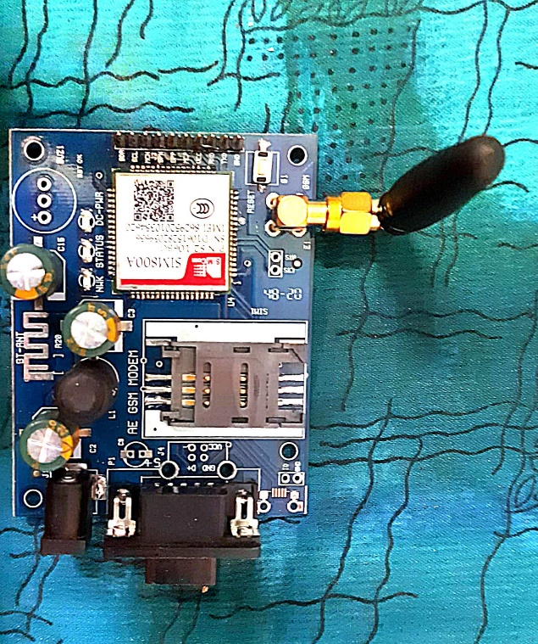

Figure.3 GSM module

D. ATMEGA 328

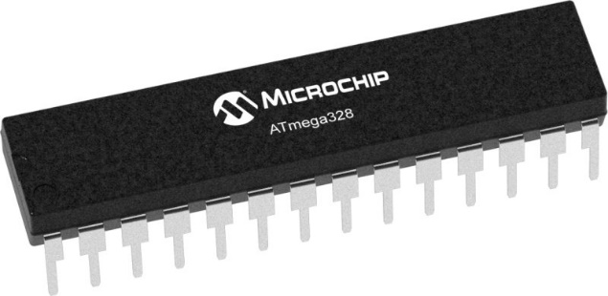

TheAtmel eight-bit AVR RISC-based totally microcontroller combines 32 KB ISP flash reminiscence with read-at the same time as-write talents, 1 KB EEPROM, 2 KB Static Random Access Memory, 23 widespread-reason I/O traces,32 general cause working registers.

ATmega328 is normally used in many areas

and [autonomous systems](https://en.wikipedia.org/wiki/Autonomous_systems) where a simple, low-powered, low-cost micro-controller is needed. Perhaps the most common implementation of this chip is on the popular [Arduino](https://en.wikipedia.org/wiki/Arduino) development platform, namely the [Arduino Uno](https://en.wikipedia.org/wiki/Arduino_Uno) and [Arduino Nano](https://en.wikipedia.org/wiki/Arduino_Nano) models.

**II. EXISTING SYSTEM**

The existing system for the detection of illegally parked car includes usage of manpower and towing vans. Traffic police are deployed to keep a check on the cars to avoid illegal parking in unauthorized area in order to avoid traffic jams and to have a smooth functioning of the traffic. The cons of the system is that it requires usage of extensive manpower along with a large overhead cost in terms of the towing van used etc. In this system , there are chances where the driver may bribe the traffic police to avoid the fine being imposed for the wrongly parked car, may evade the fine by the use of power or may not cooperate with the traffic police. Keeping all this in mind , there is a need to automate the no parking detection technique.

**III. PROPOSED SYSTEM**

Now days in many public places such as supermarkets, offices, hospital area, market areas there is a significant problem of unapproved car parking. This creates a problem on the road for the people and as well as for the authority to trace the car owner and to clear the obstruction. So, there is a need of developing an laborsaving system that indicates directly the location and the details of a car parked in an unauthorised parking area. This system includes an RFID transmitter that is attached in every bus, cab, jeep, and other vehicles[3]. RFID receiver circuits are mounted in every area where parking is prohibited. If a car parks in an unauthorized area the RFID detector detects the car and sends the notification to the driver regarding the wrongly parked car and also about the fine being imposed on the driver for the offence. The pros of this system is that less human intervention is required and any attempts to bribe or to evade the fine for the offence are nearly nullified.

**IV. LITERATURE SURVEY**

In the study [1] the author here studied about the system that consisted of RFID module, GSM modem, Infrared Sensor module, Servo motor, Arduino UNO, Arduino Mega. Here, it did not matter whether a vehicle had an RFID tag or not, as data of vehicles having no RFID tags will be verified in the particular RTO’S. The future scope involves fine and parking fee collection via e-payment and parking slot booking in advance via SMS. [2] It is based on 5 major processes Background Modelling, 1-D Projection, Segmentation, Tracking, Reconstruction. It presents a way for detecting the phenomena in real time by applying a novel image projection that reduces the dimension of the data and, thus, reduces the complexity of the segmentation and tracking processes.[3] In addition of detecting the vehicles which are falsely parked and imposing a fine on them this work allows us to book a parking slot in advance. It also presents the present number of cars, jeep, buses, and all other vehicles in the parking on the LCD. Future scope includes The Database has all the information stored related such as: type of the vehicle, model of the vehicle, registration number of the vehicle, etc , The availability of space in the parking is also shown in the LCD. [4] It reads the vehicle id and checks whether its registered or not if it is registered then it further checks the database for the check-in time and opens the gate and updates the checkout info. If the vehicle is not registered the system will not open the gate. [5] This work checks whether a vehicle is parked at no parking area or not by reading RFID tag and if a vehicle is parked in that no parking area for more than 10 sec the buzzer will ring. If the vehicle is still there after the buzzer rang the particular information of the vehicle will be sent to the nearest police station and a fine will be imposed to the owner. [6]This work works on the principle that a RFID transmitter is fitted in no parking zone. whenever a car parks in the no parking zone the transmitter receives the signal and fines the driver. It has high accuracy, does real time monitoring and is easy to use. future scope may include sending the data of the driver to the authorities and doing online fine payments [7] The work works on the principle that a proximity sensor is fitted in the no parking area so as to detect the presence of any car. Along with it, a PIR sensor is also fitted to detect the presence of the driver. once the proximity sensor detects the car, it sends data to the nearby authority. . the work requires less human intervention and helps in clearing the congestion on roads. Its future scope includes capturing the image of the car and using inductive proximity sensor to detect metal.[8] The work is divided into 2 parts. first is the parking entry where through RFID the details of the driver and of the car are collected. second part includes the parking management system, it helps in detecting a vacant spot using an ultrasonic sensor and also uses ultrasonic sensors to detect wrongly parked cars . its future scope includes of expanding the work in small area of the city. [9] The work works on the principle that an IR sensor is fitted in the areas where parking is prohibited , if a car get parked there ,the system alerts the driver and gives them a timer of 5 mins , if even after 5 mins the car is not moved , the system fines the driver based on the information received through the RFID transmitter . in future the work aims to include the system to alert the authorities for further action.

**V. WORKFLOW DIAGRAM**

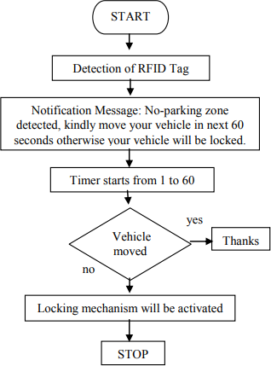

No fine is imposed

A message that the driver has been fined is sent to the driver

If the car is parked in a no parking zone, the RFID receiver detects the car and a message is sent to the driver about wrong parking

Figure .4 workflow diagram of the system

The system detects a wrongly parked car through the RFID system , if the car is moved then no fine is imposed on the driver, but if the car remains parked in the no parking zone the system automatically fines the driver and a message is sent to the driver regarding the fine being imposed for the unauthorized parking

**VI. METHODOLOGY**

The system starts with the user registering to the system for once through the GSM module. The user has to give a call to the sim number that is being used in the corresponding GSM module.

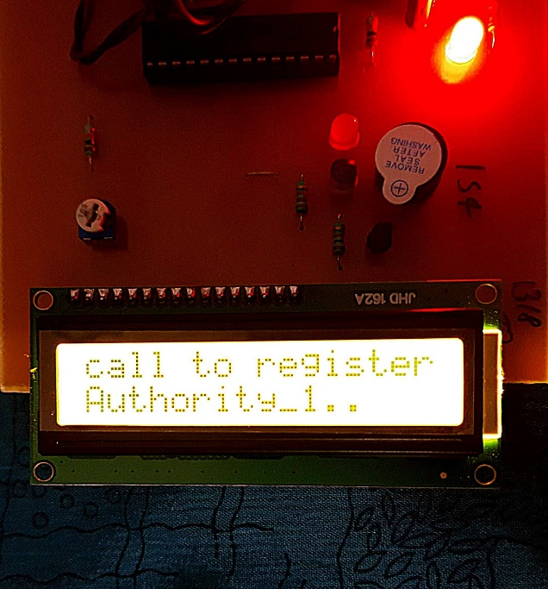

Figure 5. Screen showing calling message

Once the user has given the call, a unique RFID card is swiped that is unique to the user and it resembles the user itself. The system is having the capacity to handle two authorities at one time. Once a unique RFID card has beenallotted to the user, a message is sent to the user stating ‘ you have been registered as authority 1’. Once both the authorities are registered andeach have got a unique RFID card, the system then goes to the monitoring stage,

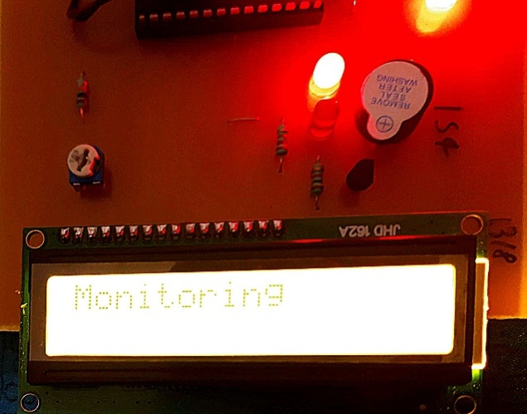

Figure 6. Monitoring stage message

in this stage the system monitors whether the car is at wrong place or not, if it is wrongly parked, the system checks for its unique RFID card and send a message to its driver stating you have been fined

**VII. ALGORITHM FOR THE PROJECT**

S1. The driver registers his number to our system by giving a missed call on our system

S2. Once call is received, the driver RFID tag is scanned and registered, the driver receives a confirmation message of registration and he is allotted an authority number

S3. If a car is already registered, then it shows already registered message and the driver does not have to register again

S4. Now once the registration is complete, the system goes in monitoring stage and here it detects unauthorized parking through detecting the RFID tags, if any registered RFID tag comes in our systems range, it warns the driver about the unauthorised parking, and gives them 5mins to move their vehicle before the fine is imposed on them, once fine is imposed the driver gets a message regarding the fine of the car.

**VIII. RESULT**

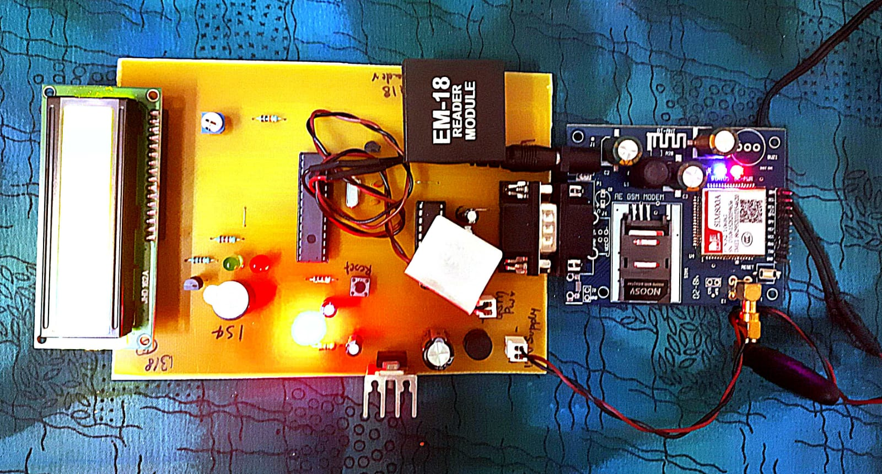

Figure 7 setup of the system



Figure 8. Message showing authority 2 being registered

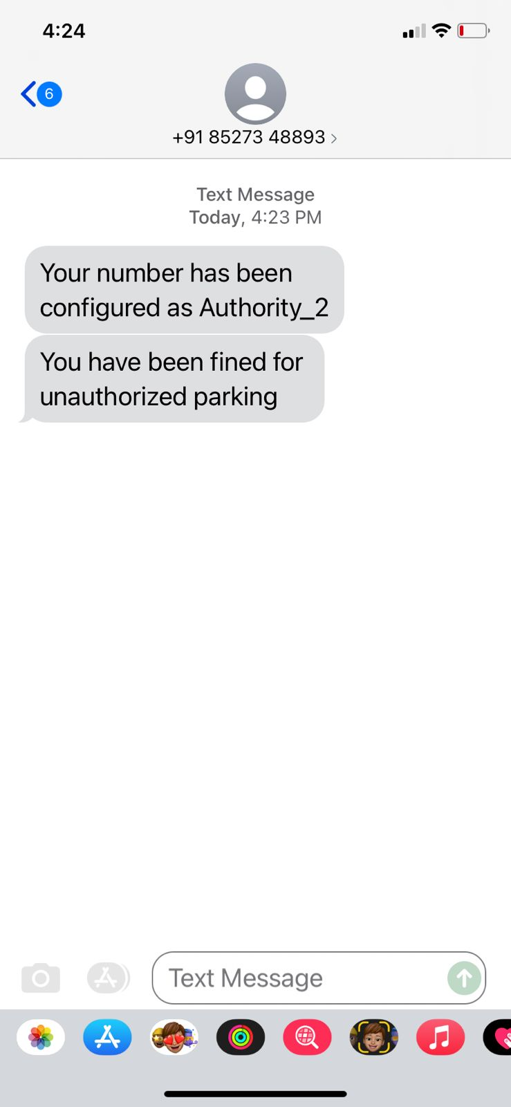

Figure 9 message showing authority 2 being fined for wrongly parked car

**IX. CONCLUSION**

The system aims to reduce the issue of unauthorized parking using automatic techniques in order to reduce the human efforts and to improve the efficiency of the entire system using the modern technology. All these issues have been addressed by our proposed system that works with the aim to improve the traffic conditions on the road so as to avoid unnecessary traffic jams due to cars being parked at unauthorized parking area. Through the system, regular monitoring can be achieved with minimum human intervention and more effective results can be obtained. The system in the future may incorporate methods to alert the nearest traffic police station about the location of wrongly parked car as well as include suspension of driving licence for repeated offence. A proper parking management software incorporated with the proposed model may be designed in the future for the public good.

**X. REFERENCES**

1. Ishraq Haider Chowdhury, AfsanaAbida, Md. Mehedi Hasan Muaz Automated Vehicle Parking System And Unauthorized Parking Detector

2 Jong T. Lee, M. S. Ryoo, Matthew Riley, J. K. Aggarwal Real-Time Illegal Parking Detection in Outdoor Environments , IEEE AUG 2019

3 S. C. Hanche, Pooja Munot, PranaliBagal, Kirti Sonawane& Pooja Pise Automated Vehicle Parking System using RFID , ISN : 2320-8945 , VOL 1 , ISSUE-2,2013

4 ZeydinPALA , Nihat inanSMART PARKING APPLICATION USING RFID , IEEE XPLORE

5 Murthy D. A ,Manjunath A ,MadhusudhanP,WarshaBalani , DESIGN AND DEVELOPMENT OF NO PARKING SYSTEM , IJARSE VOL-7, APR 2018

6 C. George Christopher, J. Vidhya Unauthorized Vehicle Parking Detection and Auto-Locking using an Arduino, IJEAT,ISSN-22498958 VOL-9 ,ISSUE-2, DEC 2019

7 M Manoj Prabhu, R Jayaraj, R Karthikeyan Automatic Unauthorized Parking Detector

IJEAT , ISSN 2249-8958,VOL-8,ISSUE-5 JUNE 2019

8 Ankita Gupta, Ankit Srivastava, Rohit Anand Smart vehicle parking monitoring system using RFID

IJITEEE , ISSN 2278-3075, VOL-8, ISSUE-9,JULY 2019

9 M.Indumathy , A. Arun Reddy , K. Jitender Reddy Avoidance of unauthorised vehicle parking IJESC, ISSN 2321-3361, VOL-10,ISSUE-5 , 2020

10 J. Cynthia, C. B. IOT based Smart Parking Management System. International Journal of Recent Technology and Engineering (IJRTE), 2018

11. Asghar Ali Shah, G. M,. Video Stitching with Localized 360 Model for Intelligent Car Parking Monitoring and Assistance System . IJCSNS International Journal of Computer Science and Network Security.2019

12. Rico, J., Sancho, J., Cendon, B., & Camus, M. Parking easier by using context information of a smart city: Enabling fast search and management of parking resources. In Advanced Information Networking and Applications Workshops (WAINA), 2013 27th International Conference on (pp. 1380-1385). IEEE. 2018

13. Ji, Z., Ganchev, I., O'droma, M., & Zhang, X. A cloud based intelligent car parking services for smart cities. In General Assembly and Scientific Symposium (URSI GASS), XXXIth URSI (pp. 1-4). IEEE.2014

14. Chen, S. Y., Lai, C. F., Huang, Y. M., & Jeng, Y. L. Intelligent home-appliance recognition over IoT cloud network. In Wireless Communications and Mobile Computing Conference (IWCMC), 9th International (pp. 639-643). IEEE.2015

15. R. H. Giva Andriana, Anak Agung, “Sensor Comparation for Smart Parking System,” pp. 4–9, 2012.

16. S. A. El-seoud, H. El-sofany, and I. Taj-eddine, “Towards the Development of Smart Parking System using Arduino and Web Technologies,” no. 978, pp. 10–16, 2016.